|  |  |  |  |
| --- | --- | --- | --- |
|  |  |  |  |

Year 8 Topic 5 – Physical Computing

Make a Physical Microbit Game

# Final Topic Project

# Do Now Task

1. Log in and Open chrome
2. Search for BBC Make Code
3. Create a new project called: Temp
4. Using the computer as required, answer the questions below.

|  |  |
| --- | --- |
| **Answer the following questions:** | |
| 1. **Describe the roles of a connection pin on a Microbit.** |  |
| 1. **What is a variable?** |  |
| 1. **What does the term iteration mean?** |  |
| 1. **Give an example of a selection statement.** |  |
| 1. **What does the term data type mean?** |  |
| 1. **What is the name for the data type that stores text information?** |  |
| 1. **What is the name for the data type that stores whole numbers?** |  |
| 1. **What is the name for the data type that stores true / false?** |  |

# Protect Goals

* **Create a simple goal game using a Microbit.**
* **Be introduced to your end of topic project.**
* **Plan, create and program a functioning physical game using a Microbit.**

# Building a Basic Goal Game

## The Plan

We are going to create a simple tabletop football game.

It will consist of a goal, a ball and the Microbit to keep score.

## You will need:

* A small piece of carboard.
* A glue sticks
* Some a pair of scissors
* Some foil
* Microbit + 2 crocodile clips.

## Method:

If your not sure what your aiming to make look at the last image in this section.

**Steps:**

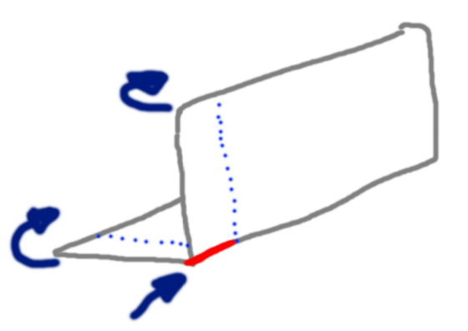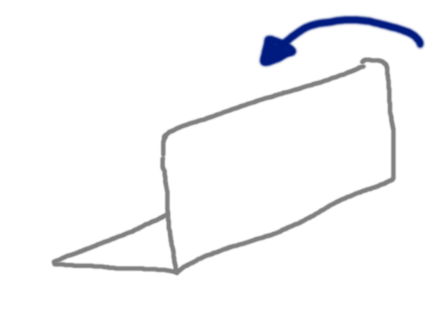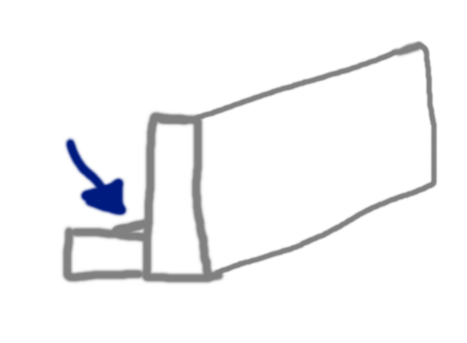

1. First get your carboard piece and fold it in about half.

1. Next cut a small line across one side of the fold. Around about 2cm long.
2. Then fold the two edges so that they overlap. This is so the goal will stand on its own.

1. Glue the overlap so that the goal will stand up on its own.
2. Cut two 1cm(ish) wide strips of foil.

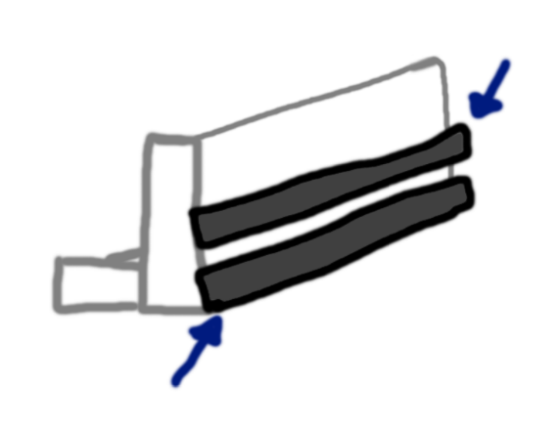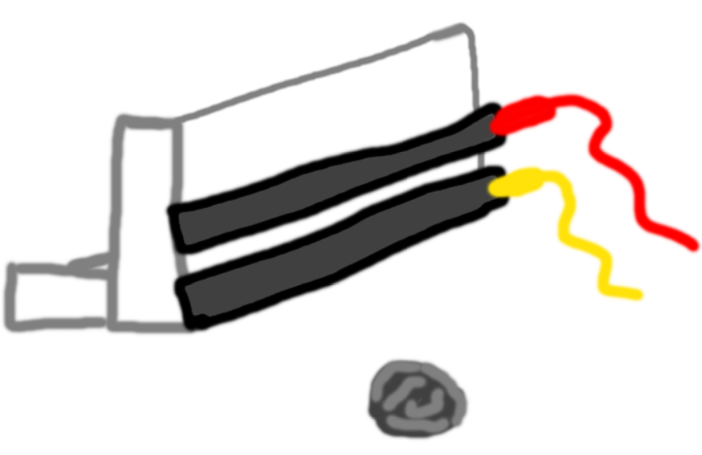

1. Attach the strips along the length of the goal.
2. Make sure that they are not touching but they do need to be close.

1. Attach a crocodile clip to the end of each bit of foil. (Colour of clips does not matter).
2. Attach one clip to pin 0 on the Microbit and the other to GND (ground).
3. Finally make a small ball of foil.

## What it should look like:

# Text, application, chat or text message Description automatically generatedProgramming a Basic Goal Game

Create the script shown in the diagram to the right.

You will need to use the:

* Variable section
* Basic section
* Input section

|  |
| --- |
| **Task – What does this scrip do? How does it work?** |
|  |

# Test & Review your Basic Goal Game

|  |
| --- |
| **Does your game work?** |
|  |
| **Could it be improved?** |
|  |

# Your challenge

You have the remaining time this term to construct something using the microbats.

It could be a physical game such as the one you have just created, something using the LED traffic lights or something using the Microbit alone.

* You might want to compose some music.
* Work with someone else so that it can send messages remotely.
* Or develop a more advanced version of rock paper scissors.

Its your time, your project but you need to create something!

# Your plan

|  |
| --- |
| **Task: Create mind map in the space below that maps out your idea of what you will create.**  **Endeavour to identify the resources you will need.** |
|  |
| **Do not skip this stage!** |

# What is your project?

|  |
| --- |
| **What are you planning on creating?** |
|  |
| **What resources will need to complete your project?** |
|  |
| **What should your finished creation do?** |
|  |

# What is the code for your game?

|  |
| --- |
| **What is the code for your final creation?** |
|  |
| **How does the code work?** |
|  |

# Review

|  |
| --- |
| **Did it work?** |
|  |
| **Did you have to make any changes to your plan to get it working?** |
|  |
| **What worked well with your final project?** |
|  |
| **What would you do to improve your final creation?** |
|  |