CPU Part 1
All about the Central Processing Unit

Do Now Task
Complete the exam style question below:
(Hint – Dictionary-based method of compression is the first method of compression we looked at and was the method you used to compress a song)
- The extract of text below is to be compressed using a dictionary-based compression method.

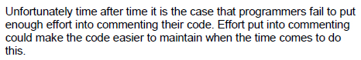

(a) Dictionary-based compression is an example of a lossless encryption method.

Explain the key difference between lossless and lossy compression methods.

___________________________________________________________

___________________________________________________________

___________________________________________________________

___________________________________________________________

(1)

(b) Explain how the extract of text in the extract above could be compressed using a dictionary-based method.

___________________________________________________________

___________________________________________________________

___________________________________________________________

___________________________________________________________

___________________________________________________________

(2)

(c) After the text in the extract above has been compressed it is to be transmitted across a computer network.

Explain why dictionary-based compression is not very effective for compressing small amounts of text for transmission.

___________________________________________________________

___________________________________________________________

___________________________________________________________

___________________________________________________________

(1)

(Total 4 marks)

Random Fact: This question is actually from A level computing. I wanted to demonstrate to you that what you have been learning not only prepares you for computing GCSE but also the Alevel as there is very little different between GCSE computing and AS level computing.

Q2.
The Huffman tree shown in Figure 1 was created to encode the string shown in Figure 2. The frequency of each character is shown in brackets. For example, the letter A appears five times within the string shown in Figure 2.
Figure 1
AAGHHGGSAAASG
Figure 2
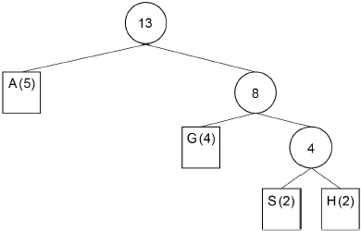
(a) Complete the code table below for characters G, S and H for the Huffman tree shown in Figure 2. The code for character A has already been completed.

Character | Binary code
A | 0
G
S
H
(3)

(b) The string shown in Figure 1 could also be encoded using ASCII. ASCII uses 7 bits to represent each character.
The Huffman tree is 25 bits long.
How many bits are saved by using Huffman coding rather than ASCII to represent the string shown in Figure 1?
You must show your working.
___________________________________________________________
___________________________________________________________
___________________________________________________________
___________________________________________________________
___________________________________________________________
___________________________________________________________
___________________________________________________________
Answer _________________________________________
(3)
(Total 6 marks)
(This question is however from the GCSE and so will all others in this worksheet)

Topic Goals
- Recap the Basics of compression
- Review and Investigate primary memory, cache, busses and the CPU.
- Investigate what Hertz measure and how its relevant to a CPU.
- Break down language levels.
- Investigate what is inside a CPU
- Discovering the Fetch, Decode and Execute cycle.
- Teach them the fetch decode and execute cycle.
- Extension – FDE in detail.

Lossy vs Lossless compression

Lossless compression

What is the benefit to lossless compression?

What is the downside of lossless compression?

What can it be used to compress?

Sound
Pictures
programs
Text

Lossy

What is the benefit of lossy compression?

What is the downside?

What can it be used to compress?

Sound
Pictures
programs
Text

Why can’t it be used to compress everything?

Where might be used and why?

Dictionary based compression.
What song did we compress using dictionary-based compression?

How did you compress that song? What was the method you used?

Researching Hardware Components
Research the following components:

RAM

What is it?

What does it look like?
Add a picture below.
What does it do?

How is it measured?

Cache (Level 1, Level 2 and Level 3)

What is it?

What does it look like?
Add a picture below.
What does it do?

How is it measured?

Motherboard
(With focus on Busses)

What is it?

What does it look like?
Add a picture below.
What does it do?

What are busses?
What types of busses can you find on/in a motherboard?
How is it measured?

CPU

What is it?

What does it look like?
Add a picture below.
What does it do?

How is it measured?

Overview of the Fetch Decode Execute Cycle

What is a clock cycle? Describe what the role of the clock is.

Describe the steps taken during the cycle.

Fetch

Decode
Execute

RISC vs CISC

What is an instruction library?

What does RISC stand for?

What does CISC stand for?

What was the difference between them?

Do they exist today?

Exam Style Questions
Complete the exam style questions below:
Q1.
The diagram below shows a simplified diagram of the Fetch-Execute cycle.
Fill in the name of the missing stage in the diagram below.
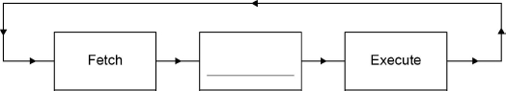
(Total 1 mark)
Q2.
Outline what happens at each of the stages of the fetch-execute cycle.
(a) Fetch
___________________________________________________________
___________________________________________________________
___________________________________________________________
(2)
(b) Decode
___________________________________________________________
___________________________________________________________
___________________________________________________________
(1)
(c) Execute
___________________________________________________________
___________________________________________________________
___________________________________________________________
(2)
(Total 5 marks)

Q3.

Explain how main memory is used during the fetch-execute cycle.
________________________________________________________________
________________________________________________________________
________________________________________________________________
________________________________________________________________
________________________________________________________________
________________________________________________________________
________________________________________________________________
________________________________________________________________
(Total 4 marks)

