**We All Came Here From Somewhere**

**Year 8 Poetry Unit**

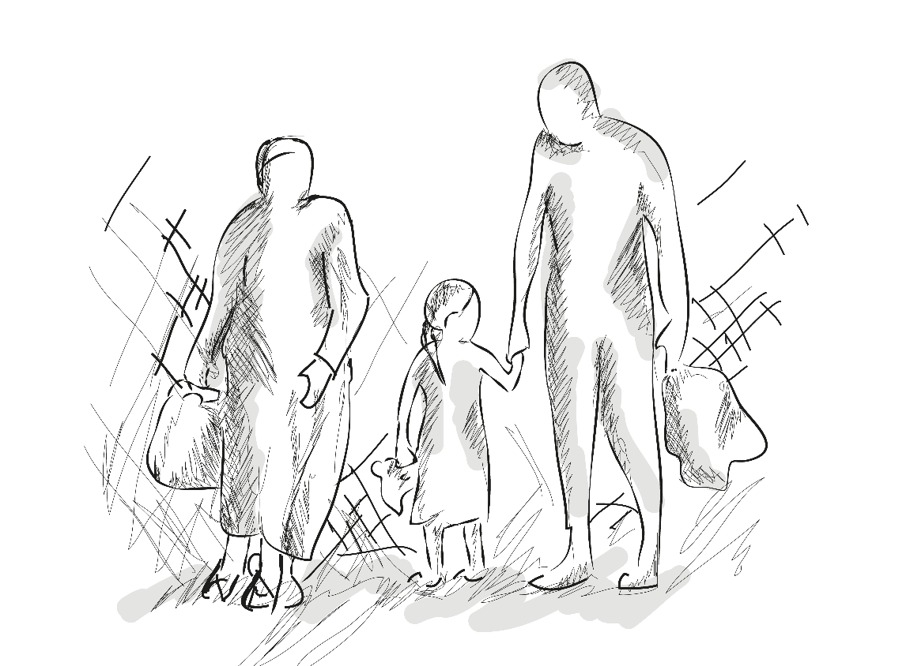

Your name: ___________________________

Teacher name: ________________________

Classroom: ___________________________

Pre-topic test

|  |  |
| --- | --- |
| What is identity? |  |
| What is culture? |  |
| What is cultural identity? |  |
| What makes someone’s cultural identity? |  |
| What is a stanza? |  |
| What is tone? |  |
| What is repetition? |  |
| What is motif? |  |
| What is a rhyming couplet? |  |
| What is juxtaposition? |  |
| What is enjambment? |  |
| What is a simile? |  |
| What is imagery? |  |
| What is a metaphor? |  |

**Do now**

**Answer the questions below to explore your own cultural identity.**

1. Where do you come from?

How do you feel about this?

________________________________________________________________________________________________________________________________________________________________________

1. In what ways are you similar to or dissimilar to your parents or carers? For example, temper personality, interests etc.

________________________________________________________________________________________________________________________________________________________________________

1. Do you have siblings? If so, how has your relationship with them influenced you? If you are an only child, how has this affected you?

________________________________________________________________________________________________________________________________________________________________________

1. What are your personal interests, hobbies or favourite activities?

How have these things influenced your life?

_______________________________________________________________________________________________________________________________________________________________________

1. What is your religion? Or lack of.

What is your family’s religion?

How do you feel about this?

________________________________________________________________________________________________________________________________________________________________________

1. What other beliefs do you have? (e.g. do you believe in an afterlife/a higher power? Fate/destiny? Good/bad luck? Ghosts/the supernatural?)

____________________________________________________________________________________________________________________________________________________________________________________________________________________________________________________________

1. Do you have any particular moral values or mottossuch as ‘always be kind’; ‘always work hard’; ‘never be late’; ‘put everything tidily in its proper place’; ‘always switch the lights off’; ‘never swear’ etc etc.

____________________________________________________________________________________________________________________________________________________________________________________________________________________________________________________________

**Match the words up to their definitions**

1. **Who a person is and how they see themselves.**
2. **A sense of belonging to a group that shares similar values such as religion, behaviours, and customs.**
3. **The ideas and customs related to a particular group or society.**

**1. Culture**

**2. Identity**

**3. Cultural identity**

**Who is the speaker of the poem?**

**What is the poem exploring?**

**What is the message of the poem?**

**Now having read the poem, explain what you think British cultural identity is.**

***‘*The British’**

1. Tick the lines you think are really effective.
2. Put question marks next to any line you are confused about.



**By Benjamin Zephaniah**

Take some Picts, Celts and Silures

And let them settle,

Then overrun them with Roman conquerors.

Remove the Romans after approximately 400 years

Add lots of Norman French to some

Angles, Saxons, Jutes and Vikings, then stir vigorously.

Mix some hot Chileans, cool Jamaicans, Dominicans,

Trinidadians and Bajans with some Ethiopians, Chinese,

Vietnamese and Sudanese.

Then take a blend of Somalians, Sri Lankans, Nigerians

And Pakistanis,

Combine with some Guyanese

And turn up the heat.

Sprinkle some fresh Indians, Malaysians, Bosnians,

Iraqis and Bangladeshis together with some

Afghans, Spanish, Turkish, Kurdish, Japanese

And Palestinians

Then add to the melting pot.

Leave the ingredients to simmer.

As they mix and blend allow their languages to flourish

Binding them together with English.

Allow time to be cool.

Add some unity, understanding, and respect for the future,

Serve with justice

And enjoy.

Note: All the ingredients are equally important. Treating one ingredient better than another will leave a bitter unpleasant taste.

Warning: An unequal spread of justice will damage the people and cause pain. Give justice and equality to all.

[*Benjamin Zephaniah*](http://www.poemhunter.com/benjamin-zephaniah/poems/)

**Planning your cultural identity poem.**

**Plan what will go in each stanza and which cooking commands you will use.**

|  |  |
| --- | --- |
| **Stanza 1** | **What nationalities or areas of Britain do your family come from? How will you mix them using the cooking command verbs?** |
| **Stanza 2** | **What are your family’s traditions? Which cooking commands will you use?** |
| **Stanza 3** | **What is your family dynamic? Do you have any siblings? Any pets?** |
| **Stanza 4** | **What are your hobbies? Which cooking commands will you use to mix them?** |
| **Stanza 5** | **What is your belief system? How does this affect you?** |
| **Stanza 6** | **What is your message about culture and Britain? Which cooking commands will you use?** |

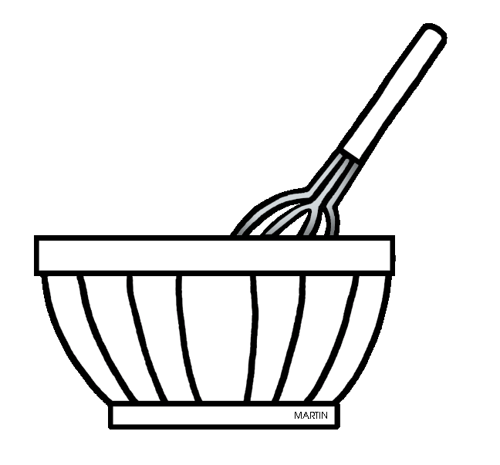**A Dictionary of Cooking Command Verbs**

**Bake:** To cook food in an oven, surrounded with dry heat; called roasting when applied to meat or poultry.

**Batter:** An uncooked pourable mixture usually made up of flour, a liquid, and other ingredients.

**Blend:** To thoroughly combine 2 or more ingredients, either by hand with a whisk or spoon, or with a mixer.

**Boil:** To cook in bubbling water that has reached 212 degrees F.

**Brown:** To cook over high heat, usually on top of the stove, to brown food.

**Caramelise:** To heat sugar until it liquefies and becomes a syrup ranging in colour from golden to dark brown.

**Cream:** The butterfat portion of milk. Also, to beat ingredients, usually sugar and a fat, until smooth and fluffy.

**Cube:** To cut food into small (about 1/2- inch) cubes.

**Dice:** To cut food into very small (1/8-to 1/4-inch) cubes.

**Dollop:** A spoonful of soft food such as whipped cream or mashed potatoes.

**Dress:** To coat foods such as salad with a sauce. Also, to clean fish, poultry, or game for cooking.

**Drizzle:** To pour melted butter, oil, syrup, melted chocolate, or other liquid back and forth over food in a fine stream.

**Do now.**

**Task 1. Key word recap. Explain what you think the words below mean.**

1. **Culture**
2. **Identity**
3. **Cultural identity**

**Task 2. Punctuate this passage with CAPITAL LETTERS and FULL STOPS.**

next week is half term i can’t wait my mum and dad have promised to take us to thorpe park and i am allowed to invite a friend i’m looking forward to having a go on the ride earthquake it’s bound to be scary

**Task 3. Pesky apostrophes. Add the missing apostrophes to the sentences below.**

1. Bens new bike was stolen, he was really distraught about it.
2. The childrens art project was ruined when it rained on their way to school.
3. James birthday was a real disappointment.
4. The boys football match was cancelled as the coach lost all of the footballs.
5. Jennys and Elizabeths house was just down the road from the zoo.

**Task 4. Punctuate this passage with CAPITAL LETTERS, COMMAS, APOSTROPHES and FULL STOPS.**

Halloween which falls on 31st october can be a really exciting time of year some people go trick or treating bob for apples or host a fancy dress party usually my friends and i get together and my best mate alice cooks up a halloween inspired feast afterwards alices parents sue and mick will let us stay up really late watching horror films

**Match the historical figures to what role they played in history.**

|  |  |  |
| --- | --- | --- |
| Image result for Sir Richard WhittingtonDick Whittington |  | She was a leader of the Jamaican Maroons and an excellent military leader in protecting her people from British invasion. |
| Image result for Toussaint L’OuvertureToussaint L’Ouverture |  | A British naval commander. |
| See the source imageNanny de Maroon  (Nanny of the Maroons) |  | This person and their cat have become famous in English folk tales. He was born poor but made his fortune and became a popular London Mayor in the 1300s. |
| See the source imageLord Nelson |  | She went to the Crimean War to be a nurse and help the wounded soldiers. She was a founder of modern medical practices. |
| See the source imageShaka de Great Zulu |  | She was a Jamaican nurse who went to the Crimean war to help soldiers on the front line. She paid out of her own money for all the assistance she gave the British troops on the front line. |
| Florence Nightingale  See the source image |  | This person was a famous Haitian general and lead a revolution which fought for independence and freedom of its people from slavery. |
| See the source imageMary Seacole |  | This person was a great Zulu king and conqueror from Africa. |

***‘*Checking Out Me History’**

**By John Agard**

Dem tell me

Dem tell me

Wha dem want to tell me

Bandage up me eye with me own history

Blind me to me own identity

Dem tell me bout 1066 and all dat

Dem tell me bout Dick Whittington and he cat

But Toussaint L’Ouverture

No dem never tell me bout dat

Toussaint

A slave

With vision

Lick back

Napoleon

Battalion

And first Black

Republic born

Toussaint de thorn

To de French

Toussaint de beacon

Of de Haitian Revolution

Dem tell me bout de man who discover de balloon

And de cow who jump over de moon

Dem tell me bout de dish ran away with de spoon

But dem never tell me bout Nanny de maroon

See-far woman

Of mountain dream

Fire-woman struggle

Hopeful stream

To freedom river

Dem tell me bout Lord Nelson and Waterloo

But dem never tell me bout Shaka de great Zulu

Dem tell me bout Columbus and 1492

But what happen to de Caribs and de Arawaks too

Dem tell me bout Florence Nightingale and she lamp

And how Robin Hood used to camp

Dem tell me bout ole King Cole was a merry ole soul

But dem never tell me bout Mary Seacole

From Jamaica

She travel far

To the Crimean War

She volunteer to go

And even when de British said no

She still brave the Russian snow

A healing star

Among the wounded

A yellow sunrise

To the dying

Dem tell me

Dem tell me wha dem want to tell me

But now I checking out me own history

I carving out me identity

**What is Agard’s message?**

**Who is the speaker of the poem?**

**What is the poem exploring?**

**What is the message of the poem?**

**Why do you think the speaker has this message?**

**Define the methods below.**

|  |  |
| --- | --- |
| **Method** | **Definition** |
| **Tone** |  |
| **Motif** |  |
| **Repetition** |  |
| **Rhyming couplet** |  |

**Find and explain the effects of the methods.**

|  |  |  |
| --- | --- | --- |
| **Method** | **Quote** | **Explanation of the effect** |
| **Tone** |  |  |
| **Motif** |  |  |
| **Repetition** |  |  |
| **Rhyming couplet** |  |  |

**How does Agard present cultural identity in the poem?**

**Write a summary or a PEEZZ answering the question.**

**Do now**

1. **Define the methods.**
2. **Write an example of them.**

|  |  |
| --- | --- |
| Simile | |
| Definition |  |
| Example |  |

|  |  |
| --- | --- |
| Imagery | |
| Definition |  |
| Example |  |

|  |  |
| --- | --- |
| Onomatopoeia | |
| Definition |  |
| Example |  |

|  |  |
| --- | --- |
| Metaphor | |
| Definition |  |
| Example |  |

|  |  |
| --- | --- |
| Enjambment | |
| Definition |  |
| Example |  |

**‘Blessing’**

1. Tick the lines you think are really effective.
2. Put question marks next to any line you are confused about.



**By Imtiaz Dharker**

The skin cracks like a pod.

There never is enough water

Imagine the drip of it,

the small splash, echo

in a tin mug,

the voice of a kindly god.

Sometimes, the sudden rush

of fortune. The municipal pipe bursts,

silver crashes to the ground

and the flow has found

a roar of tongues. From the huts,

a congregation: every man woman

child for streets around

butts in, with pots,

brass, copper, aluminium,

plastic buckets,

frantic hands,

and naked children

screaming in the liquid sun,

their highlights polished to perfection,

flashing light,

as the blessing sings

over their small bones

**Who is the speaker of the poem and/or the character?**

**What is the poem exploring?**

**What is the message of the poem?**

**Annotate the image to explore the setting of the poem.**

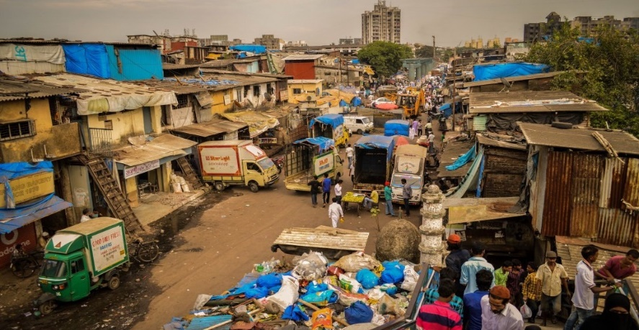

**How does the poet portray the importance of water?**

|  |  |  |
| --- | --- | --- |
| Simile.  Lines 1-2  ‘**The skin cracks like a pod.’** | Metaphor and onomatopoeia  Stanza 2 | Enjambment  The final two stanzas. |
|  |  |  |

**How does the poet portray the importance of water?**

Write a PEEZZ answering the question ‘How does the poet portray the importance of water?’

**What goes into a PEEZZ?**

Point – Answer the question and give your view.

Evidence – Introduce a quote which supports your point.

Explain – Explain what the quote suggests and what effect it has on the reader. Try picking a language or structural device and explaining the effect.

Zoom in – Pick a word from the quote and explain why it is effective.

Zoom out – Explain the author’s message. Explain what context may have influenced the writer.

**Do now**

Fill in the grids as best as you can.

|  |  |
| --- | --- |
| Word: forlorn. | |
| Define the word. |  |
| Use the word in a sentence. |  |
| Write down synonyms for the word. |  |
|  |  |
| Word: tortured. | |
| Define the word. |  |
| Use the word in a sentence. |  |
| Write down synonyms for the word. |  |
|  |  |
| Word: bewildered. |  |
| Define the word. |  |
| Use the word in a sentence. |  |
| Write down synonyms for the word. |  |
|  |  |
| Word: agony. | |
| Define the word. |  |
| Use the word in a sentence. |  |
| Write down synonyms for the word. |  |

**‘We Refugees’**

A refugee is _______________________________________________________.

Record the emotions you think a refugee may experience.

Challenge. Explain why you think a refugee may have these feelings.

**Who is the speaker of the poem?**

**What is the poem exploring?**

**What is the message of the poem?**

**‘We Refugees’**

**By Benjamin Zephaniah**

I come from a musical place  
Where they shoot me for my song  
And my brother has been tortured  
By my brother in my land.  
  
I come from a beautiful place  
Where they hate my shade of skin  
They don't like the way I pray  
And they ban free poetry.   
  
I come from a beautiful place  
Where girls cannot go to school  
There you are told what to believe  
And even young boys must grow beards.   
  
I come from a great old forest  
I think it is now a field  
And the people I once knew  
Are not there now.   
  
We can all be refugees  
Nobody is safe,  
All it takes is a mad leader  
Or no rain to bring forth food,  
We can all be refugees  
We can all be told to go,  
We can be hated by someone  
For being someone. 

I come from a beautiful place  
Where the valley floods each year  
And each year the hurricane tells us  
That we must keep moving on.   
  
I come from an ancient place  
All my family were born there  
And I would like to go there  
But I really want to live.   
  
I come from a sunny, sandy place  
Where tourists go to darken skin  
And dealers like to sell guns there  
I just can't tell you what's the price.   
  
I am told I have no country now  
I am told I am a lie  
I am told that modern history books  
May forget my name.   
  
We can all be refugees  
Sometimes it only takes a day,  
Sometimes it only takes a handshake  
Or a paper that is signed.  
We all came from refugees  
Nobody simply just appeared,  
Nobody's here without a struggle,  
And why should we live in fear  
Of the weather or the troubles?  
We all came here from somewhere.

[*Benjamin Zephaniah*](http://www.poemhunter.com/benjamin-zephaniah/poems/)

Exploring the experiences portrayed in *We Refugees*.

Define the following devices.

* Repetition is
* Juxtaposition is
* Enjambment is
* A pronoun is

|  |  |  |
| --- | --- | --- |
| **Device** | **Example** | **Explanation** |
| **Pronoun** | ‘I’ and ‘my’ | Zephaniah uses the pronoun ‘I’ to suggest  I think the poet uses the pronoun ‘my’ to show |
| **Repetition** | ‘we’ | Zephaniah repeats the pronoun ‘we’ to |
| **Juxtaposition** |  |  |
| **Enjambment** |  |  |

**Do now**

Task 1. For the words below mind-map as many synonyms as you can for them.

Forlorn

Sad

Scared

Lost

Task 2. Read the words in the sentences. Then explain what you think the word means.

1. **Tenderly she hugged her daughter.**

Tenderly means ___________________________________________.

1. **The odour of wet shoes rose up the stairs from the hallway.**

Odour means ___________________________________________.

1. **The bundle of dirty laundry sat untouched in the washing basket.**

Bundle means ___________________________________________.

1. **You have to face the consequences of your actions.**

Consequence means _______________________________________.

What is a refugee camp?

List the experiences a parent may feel in a refugee camp. What emotions might they feel and why?

Predict what you think the poem will be about and explain what has made you come to your prediction.

Sentence ideas

I think the poem will be about __________________. I think this because ____________. I think the poem will also ______________________.

|  |
| --- |
|  |
|  |
|  |
|  |
|  |

**‘Mother In A Refugee Camp’**

**By Chinua Achebe**

No Madonna and Child could touch

1. Tick the lines you think are really effective.
2. Put question marks next to any line you are confused about.



Her tenderness for a son

She soon would have to forget. . . .

The air was heavy with odors of diarrhea,

Of unwashed children with washed-out ribs

And dried-up bottoms waddling in labored steps

Behind blown-empty bellies. Other mothers there

Had long ceased to care, but not this one:

She held a ghost-smile between her teeth,

and in her eyes the memory

Of a mother’s pride. . . . She had bathed him

And rubbed him down with bare palms.

She took from their bundle of possessions

A broken comb and combed

The rust-colored hair left on his skull

And then—humming in her eyes—began carefully to part it.

In their former life this was perhaps

A little daily act of no consequence

Before his breakfast and school; now she did it

Like putting flowers on a tiny grave.

**Who is the speaker of the poem and/or who is the character in the poem?**

**What is the speaker feeling and why are they feeling this?**

**What is the poem exploring?**

**What is the message of the poem?**

Structural analysis

What is a stanza?

How many stanzas does the poem have?

What does the length of the poem and the number of stanzas suggest?

What is enjambment?

|  |  |
| --- | --- |
| **Example of enjambement** | **Explanation of effect** |
|  |  |

Using structure for effect

Use the picture and the questions below to plan and write a poem inspired by the image. Your poem must explore the idea of being trapped.

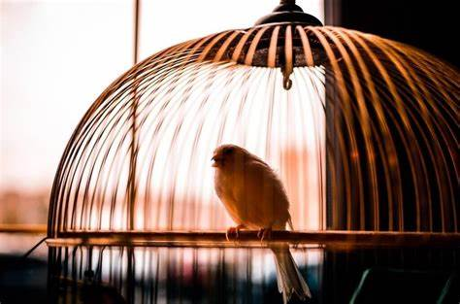

* **To show entrapment how long should your paragraphs be?**
* **To show entrapment how long will your poem be?**
* **Will you use enjambment or finish every sentence with a full stop?**
* **Will you write as the bird wanting escape? As someone watching the bird? Or someone else?**
* **Describe thoughts, feeling, senses, what you can see, smell, and hear?**

**What will you write about in the sections below?**

**Opening**

**Middle**

**End**

**Do now**

**Fill the gaps in the sentences from the box. Only use each word once**.

Melancholy

Exhilarating

Writhing

Agony

Engulfed

Ravenously

Billowed

Scarpered

1. The ___________________ trees sighed in the wind.
2. ___________ surged through the boy as he slipped and broke his leg.
3. Hattie was _______________ hungry as she’d forgotten her lunch.
4. The rollercoaster was ____________________.
5. Ben was _________________ in pain as he’d just kicked a cactus.
6. The smoke ______________ the room as the roast was burnt.
7. The curtains _________________ through the window during the storm.
8. The children __________________ from the park as the grumpy warden strode towards them.

**Write one synonym for each of the words in the box. The first one has been done for you.**

|  |  |  |  |
| --- | --- | --- | --- |
| **Sad**  **Miserable** | **Sad** | **Sad** | **Sad** |
| **Happy** | **Happy** | **Happy** | **Happy** |
| **Bad** | **Bad** | **Bad** | **Bad** |
| **Dark** | **Dark** | **Dark** | **Dark** |
| **Cold** | **Cold** | **Cold** | **Cold** |
| **Small** | **Small** | **Small** | **Small** |

**SPaG DIRT**

**Pick three words from your paragraph and upgrade them. For each word write three exciting synonyms.**

**1**

**2**

**3**

|  |  |  |  |  |  |
| --- | --- | --- | --- | --- | --- |
| Copy | Write | Check | Copy | Write | Check |
|  |  |  |  |  |  |
|  |  |  |  |  |  |
|  |  |  |  |  |  |
|  |  |  |  |  |  |
|  |  |  |  |  |  |
|  |  |  |  |  |  |

**Pick your three favourite synonyms and use them in a sentence.**

**1**

**2**

**3**

**DIRTing your spelling.**

**For all the words you have misspelt, copy, write and check the correct spelling until you are confident in how to spell them correctly.**

**Do now**

|  |  |
| --- | --- |
| **I will** |  |
| **Do not** |  |
| **Cannot** |  |
| **I have** |  |
| **Have not** |  |
| **Will not** |  |
| **I do** |  |
| **Could not** |  |

1. **Write the contracted versions of the words.**
2. **Put the apostrophes in the correct place to show possession.**
3. Matts car.
4. The childrens ball.
5. The chickens eggs.
6. The dogs stick.
7. The donkeys carrot.
8. Mums ice cream.
9. Mr. Hendricks bag.
10. **Write one synonym for each of the words in the box. The first one has been done for you.**

|  |  |  |  |
| --- | --- | --- | --- |
| **Cold**  **Frozen** | **Cold** | **Cold** | **Cold** |
| **Big** | **Big** | **Big** | **Big** |
| **Sad** | **Sad** | **Sad** | **Sad** |
| **Lonely** | **Lonely** | **Lonely** | **Lonely** |
| **Good** | **Good** | **Good** | **Good** |
| **Boring** | **Boring** | **Boring** | **Boring** |

**Juxtaposing locations**

**What would it be like if you were in these locations? What would living in these two places be like?**

* **What experiences would you be used to?**
* **What can you see, smell, hear, taste, and feel?**

**1**

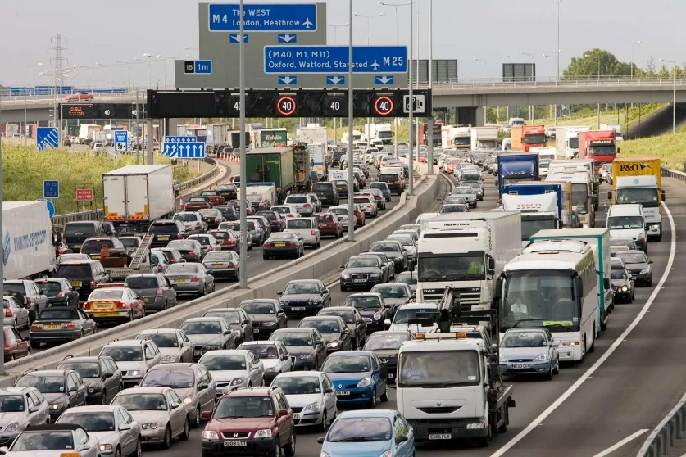

**2**

**How do you think someone living in image 1 would feel if they moved to image 2?**

**Exploring the poem ‘Island Man’**

**Before reading the poem, predict what it will be about and why you think this.**

**Sentence prompts**

I think the poem will be about ____________________. I think this because ______________.

**Word wise**

Word: wombing

|  |  |
| --- | --- |
| Think of meaning |  |
| Think of sound |  |
| Think of a sentence |  |

Word: muffling

|  |  |
| --- | --- |
| Think of meaning |  |
| Think of sound |  |
| Think of a sentence |  |

Word: surge

|  |  |
| --- | --- |
| Think of meaning |  |
| Think of sound |  |
| Think of a sentence |  |

**‘Island Man’**

1. Tick the lines you think are really effective.
2. Put question marks next to any line you are confused about.



**By Grace Nichols**

Morning

and island man wakes up

to the sound of blue surf

in his head

the steady breaking and wombing

wild sea birds

and fishermen pushing out to sea

the sun surfacing defiantly

from the east

of his small emerald island

he always comes back groggily groggily

Comes back to sands

of a grey metallic soar

to surge of wheels

to dull north circular roar

muffling muffling

his crumpled pillow waves

island man heaves himself

Another London day.

**Who is the speaker of the poem and who are they speaking about?**

**What is the character feeling and why are they feeling this?**

**How does the poem explore cultural identity?**

**What is the message of the poem?**

**What is the message of the poem?**

Explain what you think the Island Man’s experience is moving from an Island to inner city London. What is the poem trying to portray?

**Revising poetic devices**

Match the method to the definition.

|  |  |
| --- | --- |
| **Device** | **Definition** |
| Juxtaposition |  |
| Imagery |  |
| Repetition |  |
| Onomatopoeia |  |
| Metaphor |  |
| Enjambment |  |

* A repeated word or phrase.
* When an image is created in the reader’s head.
* When the sentence runs over multiple lines.
* When a word sounds like the noise it’s describing.
* Two opposites near each other.
* When something is said to be something else to describe it and/or represent a wider meaning.

Analysing the poem ‘Island Man’

How does the structure of the poem present the experience of the Island Man?

1. How does the poem start?
2. How does the poem end?
3. How is this juxtaposing? How does the Island Man feel?

**Write a quote and explain how enjambment presents the experience of the Island Man.**

**Find examples of the methods and explain the effect, focusing on how the Island Man’s experience is presented.**

|  |  |  |
| --- | --- | --- |
| **Poetic device** | **Example from the poem.** | **Explain how the Island Man’s experience is presented.** |
| **Imagery** |  |  |
| **Metaphor** |  |  |
| **Onomatopoeia** |  |  |
| **Repetition** |  |  |
| **Juxtaposition** |  |  |

**Do now**

**Read the extract below.**

Another monotonous never-ending day. Another day where the grey sky despairingly hung listlessly over the pollution-blackened concrete flats where I lived. Another day where I’d have to go through the motions of life, but feeling nothing, no warmth, no joy. Enduring the days, waiting with bated breath till they come to an end and then feeling emptiness consume you as your reward, that, that is not living.

This is not what I had expected when I arrived here.

I faded back into my memories, a much more pleasant land. A land with sweet coconut and sea salt infused breeze, where waves lap gently and there’s symphony of bird song. The invigorating freedom of my home was calling me back.

**Replace the word highlighted with vocabulary from this extract**.

1. Sadly, I walked home, knowing I was facing the scolding of a lifetime.

_____________, I walked home, knowing I was facing the scolding of a lifetime.

1. The laps my coach made me do of the pool were so boring.

The laps my coach made me do of the pool were so _________________.

1. Quick, cold swims in the sea are so refreshing!
2. Quick, cold swims in the sea are so_______________!

**Study the word wheel below. The words in the middle are not very impressive. Use the words in the outer rings to write four sentences.**

**1**

**2**

**3**

**4**

**Planning the KAP**

Question: ‘How does the writer explore the experiences of the Island Man?’

Discuss and answer the questions. Use quotes to support your answers.

1. How does the Island Man feel in the poem? Why does he feel this way?
2. What is the message of the poem? What is the poet trying to tell you?
3. How do you react to the poem? What do you think and feel?
4. How does the poem start?
5. How does the poem end?
6. Why are the beginning and end of the poem so different?
7. What are the main images in the poem?
8. **Paragraph plan 6. Write the thesis.**

4. FINAL ARGUMENT/

THESIS

**PP**

**1. ……**

**2…….**

**3…….**

**4……**

**5…..…..**

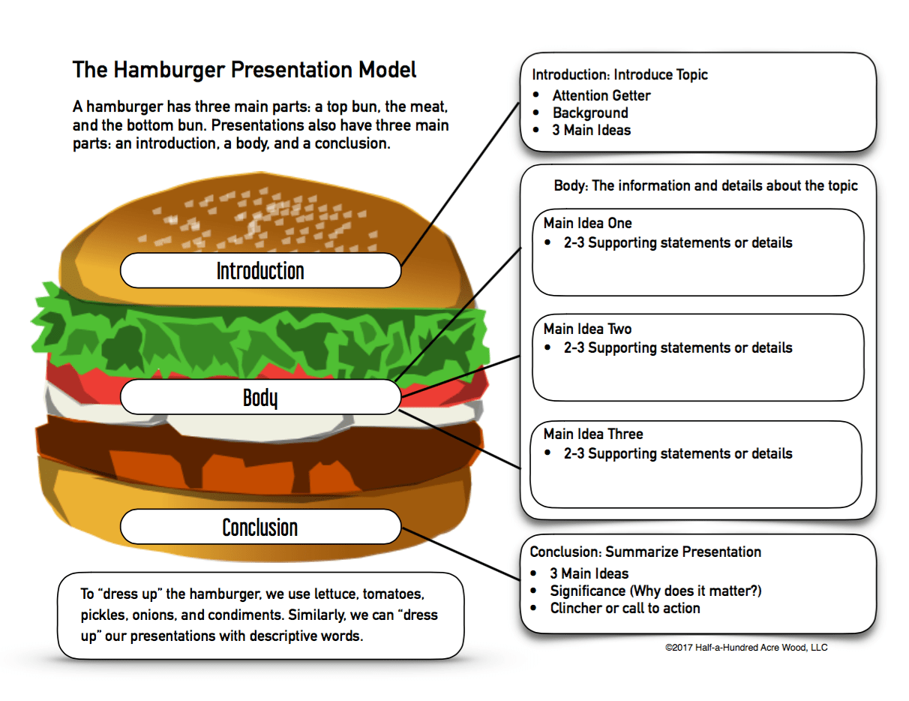

1. **Consider the question**  **2. Initial ideas** **3. Re-reading**

Close reading

Overall interpretation

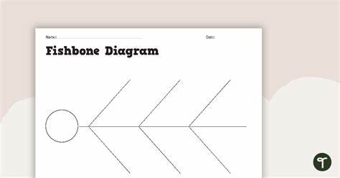

**7. Write the rest of the essay**

**‘How does the writer explore the experiences of the Island Man?’**

Introduction

PEEZZ 1.

|  |  |
| --- | --- |
| Point |  |
| Evidence | The quote … |
| Explain | What does the quote imply?  What is the method and what is the effect?  What is your reaction? |
| Zoom in | The word … |
| Zoom out | I think the message is …. |

PEEZZ 2

|  |  |
| --- | --- |
| Point |  |
| Evidence | The quote … |
| Explain | What does the quote imply?  What is the method and what is the effect?  What is your reaction? |
| Zoom in | The word … |
| Zoom out | I think the message is …. |

PEEZZ 3

|  |  |
| --- | --- |
| Point |  |
| Evidence | The quote … |
| Explain | What does the quote imply?  What is the method and what is the effect?  What is your reaction? |
| Zoom in | The word … |
| Zoom out | I think the message is …. |

PEEZZ 4 (optional)

Conclusion

|  |  |
| --- | --- |
| Point |  |
| Evidence | The quote … |
| Explain | What does the quote imply?  What is the method and what is the effect?  What is your reaction? |
| Zoom in | The word … |
| Zoom out | I think the message is …. |

Post-topic test

|  |  |
| --- | --- |
| What is identity? |  |
| What is culture? |  |
| What is cultural identity? |  |
| What makes someone’s cultural identity? |  |
| What is a stanza? |  |
| What is tone? |  |
| What is repetition? |  |
| What is motif? |  |
| What is a rhyming couplet? |  |
| What is juxtaposition? |  |
| What is enjambment? |  |
| What is a simile? |  |
| What is imagery? |  |
| What is a metaphor? |  |

**SPaG DIRT**

**Pick three words from your paragraph and upgrade them. For each word write three exciting synonyms.**

**1**

**2**

**3**

|  |  |  |  |  |  |
| --- | --- | --- | --- | --- | --- |
| Copy | Write | Check | Copy | Write | Check |
|  |  |  |  |  |  |
|  |  |  |  |  |  |
|  |  |  |  |  |  |
|  |  |  |  |  |  |
|  |  |  |  |  |  |
|  |  |  |  |  |  |

**Pick your three favourite synonyms and use them in a sentence.**

**1**

**2**

**3**

**DIRTing your spelling.**

**For all the words you have misspelt, copy, write and check the correct spelling until you are confident in how to spell them correctly.**