GTS CURRICULuM 2025 – 2026

# OUR ethos

At GTS, our aim is to ensure that all pupils are able to make outstanding progress in their learning and personal development in their 5 years with us. We will evaluate each cohort as they join GTS and based on the academic profile and pastoral information, we will determine the best learning pathway for all the pupils.

This document outlines how we allocate time to each subject that is taught at GTS and how we approach our curriculum.

# CURRICULUM INTENT

The GTS curriculum will give pupils the academic knowledge, vocational skills and emotional literacy to pursue their dreams.

Through the curriculum and wider opportunities at GTS, we intend to:

* Provide pupils with rich knowledge, skills and deep conceptual understanding of the world, so that pupils can take advantage of the opportunities, responsibilities and experiences of later life.
* Ensure pupils are highly literate, numerate and creative.
* Ensure disadvantaged pupils have a curriculum that enables them to make progress in line with their peers.
* Grow aspirations.
* Ensure our pupils become life-long learners by promoting their happiness and both physical and mental health.

# CURRICULUM IMPLEMENTATION

## Key STage 3: - Years 7 - 9

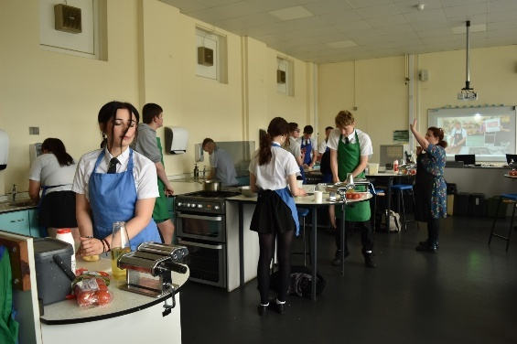

We follow a three-year Key Stage 3.

Our Key Stage 3 curriculum has the intent to ensure a smooth transition into secondary school and then to build the knowledge and skills required to be successful at GCSE and other Level 1/2 vocational subjects. By the end of Key Stage 3, learners will have developed the following key learning skills:

**Homework** – Having the skills and motivation to learn from home, including meeting deadlines for work.

**Effort** – Embracing challenge and persevering in the difficult task of learning.

**Accomplishment** – Displaying behaviour for learning, relating to others, and completing work in a professional way.

These skills will be taught, developed, and reported on in all subjects.

From Year 7 all subjects will be taught as independent subjects to allow pupils to fully understand and experience each subject allowing them to make truly informed choices for their GCSE options.

On entry to Year 7 pupils will either study French or Spanish. This is to allow them to be fully prepared for the GCSEs in Years 10 and 11.

All pupils have a broad and balanced curriculum regardless of ability and one that meets the statutory requirements of Careers Education (Gatsby Benchmarks), Religious Education, PSHE and PE.

### How will I know my child is making progress?

Each of the three skills will be reported on in all their subject areas. Homework, Effort and Accomplishment are graded on a 4-point scale. 1 Excellent, 2 Good, 3 Coasting, 4 Cause for concern.

Each pupil is assigned a flightpath when they join us in Year 7. The flightpath is based on either the pupil’s Key stage 2 SAT score or the CAT (Cognitive Ability Test) if SATS were not taken. The Flightpaths are A-E.

Pupils’ academic performance will be reported against their Flightpath grade as GDS (Greater Depth than the Standard required - at least one grade above their flightpath), EXS (At expected standard – at the flightpath grade), WTS (Working Towards the expected Standard – one grade below their flightpath) and BLW (Below the required standard – 2 grades below their Flightpath). These are linked to the pupils’ flightpath. This will be alongside the pupil’s current working at grade in that subject.

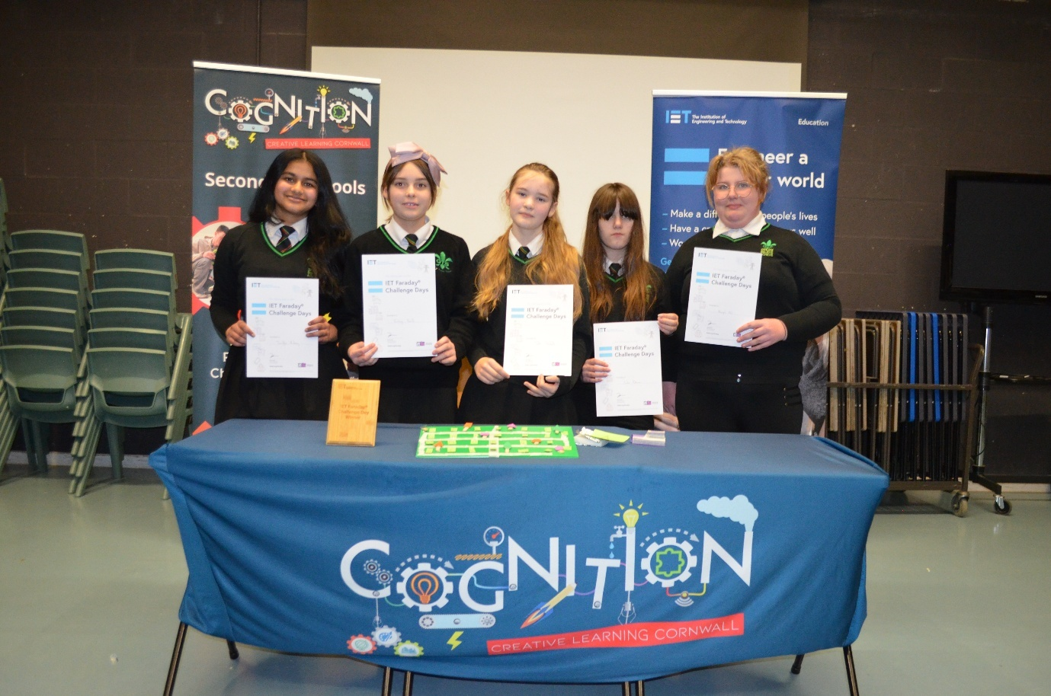

### KS3 Curriculum ALlowance: Years 7 – 9

All lessons are 1 hour long. There are no double lessons.

|  |  |  |  |
| --- | --- | --- | --- |
| Subject | Number of lessons per fortnight | | |
|  | Year 7 | Year 8 | Year 9 |
| English | 6 | 6 | 6 |
| Mathematics | 6 | 7 | 7 |
| Science | 6 | 7 | 9 |
| DT (Design Technology) | 4** | 4** | 2 |
| History | 3 | 3 | 3 |
| Catering | 4** | 4** | 2 |
| Geography | 3 | 3 | 3 |
| RE (Religious Education) | 2 | 2 | 2 |
| PSHE (Personal, Social & Health Education) | 1 | 1 | 1 |
| Personal Development & Careers | 1 | 1 | 1 |
| Art & Design | 2 | 2 | 2 |
| Drama | 2 | 2 | 2 |
| Music | 2 | 2 | 2 |
| Modern Foreign Languages  (French or Spanish) | 3 | 3 | 3 |
| Computing | 3 | 3 | 3 |
| Physical Education | 4 | 4 | 4 |
| Life Skills/Supported learning* |  |  |  |
| Read Aloud | 10 | 10 | 10 |
| Enrichment & Intervention | 2 | 2 | 2 |

*\*Pupils individual learning needs are considered and intervention time for those pupils who require additional support and guidance in relation to their peers is provided alongside the mainstream curriculum.*

*\*\*Design Technology and Catering carousel termly across years 7 & 8. By the end of Year 8 all pupils will have experienced 3 units of catering and 3 of DT. Except 7K and 8K*

## KEY STAGE 4 CurriculuM: - Years 10 - 11

At GTS, Key Stage 4 (KS4) is taught over Years 10 and 11. The aim of the KS4 curriculum is to give the pupils the best possible chance of attaining up to 11 GCSE, or equivalent, passes. The number of qualifications entered will be dependent on the pupil’s learning pathway and enrichment choice. All pupils at Key Stage 4 will study up to 4 option subjects. The pupils will also study all the core subjects of English, Mathematics, Science, Careers, RE, PSHE and practical PE. The latter three are not assessed.

At GTS, we will ensure that all pupils will continue to study the courses that are most appropriate to their learning needs and will develop a curriculum to meet the needs of the GCSEs and other high value courses that we offer. Pupils are encouraged to follow the English Baccalaureate1 if this is the correct pathway for them, thus ensuring that they have the best possible foundation for applying to college and university.

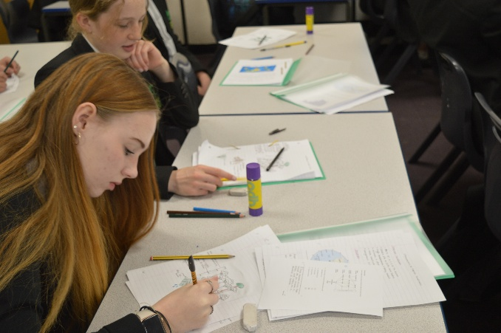All pupils study GCSE English Language, GCSE English Literature and GCSE Mathematics or functional skills/Entry level courses in these subjects. All pupils are being taught the Science GCSEs; either GCSE Combined Science (Trilogy) or GCSE Chemistry, GCSE Biology and GCSE Physics (Triple Award Science). Pupils in year 11 were selected to study ‘Triple Award Science’ based on ability and interest in science. In year 10 Triple Science is an option subject. There is usually one group of up to 30 per year. The GCSE Combined Science is equivalent to two GCSEs but does cover aspects of all three Sciences: Biology, Chemistry and Physics. Following triple or double science does not impact on the pupil’s future career paths as either science course prepares pupils for A levels in science.

GCSE Mathematics and Sciences are tiered examinations. This means that pupils will be entered for the higher (9-4) or foundation (5-1) papers and set according to expected outcome. These subjects are taught in ability groups. GCSE French and GCSE Spanish are also tiered examinations. As these are option subjects, classes are taught as mixed ability.

Most option subjects taught at GTS will be DfE approved ‘high value’ GCSE or vocational qualifications. The exception being Functional Skills (Entry Level) and The Princes’ Trust L1/L2 in Personal Development & Employability Skills. Most subjects that are studied at GTS are full course, meaning that they are equivalent to one GCSE. The only exception being the GSCE Combined Science which is equivalent to two GCSE passes.

We do enter some pupils for Cambridge Nationals, WJEC/EDUQAS and RSL courses if it is appropriate to their learning needs and post-16 learning pathway. These are all equivalent to one GCSE. For Citizenship & Careers pupils in Year 10 will have the opportunity to complete the Princes’ Trust Aspire Award in Personal Development & Employability Skills at Level 1/2.

Some pupils are further supported by Functional Skills Entry Level (below GCSE level). These pupils may also study further units of the Princes Trust Level 1 /2 in Personal Development & Employability Skills to complete the Extended Certificate or Diploma. These are recognised by FE Colleges and are suitable for the learning and future pathway of the pupil.

GTS does include the possibility of participating in work-based learning in Years 10 and 11; this has proven very successful for several pupils who have gone on to apprenticeships with the same employer. We are very proud of our links with local employers.

1 The ‘golden standard’ of the English Baccalaureate comprises of GCSEs in English language and Literature, Mathematics, Science, Geography or History and a Modern Foreign Language

### How will I know my child is making progress?

Each of the key learning skills will be reported on in all their subject areas. Homework, Effort and Accomplishment are graded on a 4-point scale. 1 Excellent, 2 Good, 3 Coasting, 4 Cause for concern. Knowledge will be on a GCSE 1-9 grade or vocational learning grade of a Level 1 Pass – Level 2 Distinction*. More details of this are published with the reports.

### curriculum subject allowance: ks4

|  |  |  |
| --- | --- | --- |
|  | Number of lessons per fortnight | |
| **year 10** | **year 11** |
| English | 8 | 8 |
| Mathematics | 6 | 8 |
| Science | 8 | 10 |
| Option A | 5 | 5 |
| Option B | 5 | 5 |
| Option C | 5 | 5 |
| PSHE | 1 | 1 |
| RE | 1 | 1 |
| Personal Development & Careers | 1 | 1 |
| Physical Education | 3 | 4 |
| Enrichment & Intervention | 2 | 2 |

## How do i support my child?

During Key Stage 3 and beyond, learners will be asked to complete regular homework tasks.

There is an expectation that pupils read for a minimum of 20 minutes each day at home, either on their own or to an adult, a mixture of both is ideal.

Subject specific homework will also be set using Class Charts. Please help your child to be organised and ensure that this system is checked regularly, and this homework is completed. We use several remote learning packages that can be accessed via the internet. These will always be signposted via Show my Homework.

## My child has a learning difficulty, how will their needs be met?

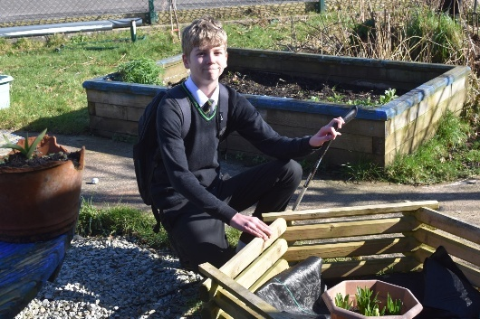Staff work in close liaison with Helen Whiterod (INCO/SENDCo) to understand how to meet the needs of all our learners. Throughout pupil’s needs are identified and met through the GTS Individual Needs Framework which works in alignment with the Devon Graduated Response Framework.

All pupils receive support during the Guided Choices process. Those pupils who have an EHCP will meet with the INCO and their parent/carer to look at what pathway would be most suitable to meet their needs. We may provide individual pathways for some pupils, ensuring that they make the best progress possible.

### Policy Statement on Special Educational Needs (SEN)

All teachers are teachers of special educational needs. It is the teacher’s responsibility to meet the needs of all children in their class through their classroom organisation, teaching materials, teaching style and scaffolded in line with the SEND 2014 Code of Practice Policy.

### Guiding Principle for SEN

Our guiding principle is one of inclusion. We want to identify and break down possible barriers to learning.

In making provision for pupils with SEND we:

* Value all our pupils equally and are committed to enable them to experience success.
* Ensure that all pupils have equal access to a broad, balanced curriculum which is scaffolded to meet individual needs and abilities.
* Recognise that it is the responsibility of all teachers to identify and meet the SEND of pupils. SEND crosses all curriculum areas and all aspects of teaching and learning.
* Recognise that high quality teaching and learning is good practice for all pupils.
* Recognise that any pupil may encounter difficulties in school at some stage.
* Acknowledge that all special educational provision is more effective if pupils and parents are fully involved. As a result, we will seek the views of parents and pupils.

Further details of the way these principles are achieved can be found in the school’s Special Educational Needs policy document.

## My Child is a high achiever, How will they continue making Rapid Progress?

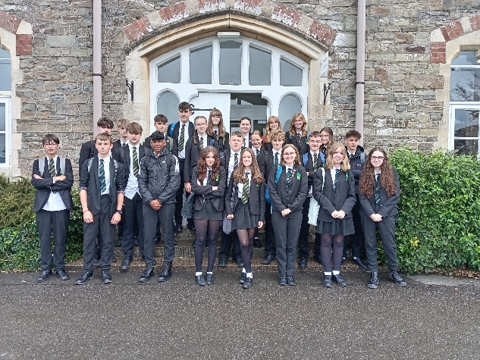Gifted children thrive most when they are accelerated through the curriculum or given time to delve deeply into one aspect of a subject.

High achieving pupils make good progress at GTS. All teachers know who their high achievers are, and they ensure their lessons are planned with enough challenge and depth for every child. A wide range of enrichment activities are offered, from university visits to national athletics competitions, choirs to robot programming - all to enable high achievers to thrive in their chosen field.

These are identified using several criteria: academic attainment and aptitude, outstanding ability and performance (e.g. sport, music, drama) and teacher input. Once identified, pupils are encouraged to stretch and further their gift or talent through a variety of activities and opportunities.

## enrichment and intervention

Every pupil at GTS has one period of Enrichment and Intervention a week and completes three 10-12 week courses a year of enrichment activities. This gives our pupils unique opportunities within North Devon to participate in a range of activities ranging from: STEM Awards (science, technology, engineering and mathematics), Media Studies, Chess, sports academies (for football, rugby, cricket & netball), community art projects, enterprise schemes, Greek mythology, theatre productions, leadership awards and a range of languages including Latin, Italian and Cultural Studies. All pupils get to opt for their enrichment activities for the next academic year in the summer.

All activities are taught in mixed year groups except the sports academies which are key stage specific. This allows our pupils to unite over a common interest and to develop friendships across year groups.

Many of the enrichment activities are certified through national award schemes that will enhance not only the pupils’ CVs but, most importantly, gives our pupils an opportunity to excel and express their skills and abilities, beyond what the curriculum allows, whether they progress to following traineeship, an apprenticeship, or an Oxbridge degree. Pupils will also be allocated intervention in 10-12 weeks blocks, if they have been identified as needed support to make expected progress in either the core subjects of English or Mathematics or, in Year 11, towards their option subjects. As a result of the Covid Pandemic we are ensuring that E&I continues to help support pupils both in their academic advancement and in the mental health and wellbeing.

## PSHE: Personal, Social & Health education

PSHE is part of the school programme for all pupils. It is delivered to each year group (7 – 11) by a dedicated and enthusiastic team following well-developed schemes of work. Links with the wider community are embraced and encouraged. Regular visitors and guest speakers deliver specific areas of the course offering a wealth of experience to equip our pupils with the skills to be empowered and forward-thinking individuals.

The school places a strong emphasis on the proper consideration of moral and social issues as well as health, drugs, relationship and sex education and citizenship (all age appropriate). If parents have any questions about the content of PSHE or Personal Development lessons, then in the first instance they can contact Charis Furness.

The school prides itself in responding to emerging issues within society – last year alone we have discussed immigration, terrorism, knife crime, gender identity and anti-social behaviour. We are proud to address these areas and to be there for our pupils.

The following areas are covered by PHSE: This includes drugs and alcohol education, emotional health and well-being, sex and relationships (with an emphasis on healthy relationships), nutrition and physical activity, personal finance, safety, careers education and work related/enterprise learning.

**Right of withdrawal:** *the right of withdrawal from RSE (Relationship and Sex Education) stands for all parents and teachers.*

## Careers Education and Guidance

GTS works closely with The Careers and Enterprise Company, Careers South West and Peninsula Training Ltd who, together with the school’s own experienced personnel, aim to provide the very best careers education and guidance for our pupils.

Since January 2018 it has become a legal requirement for all schools to provide Careers Guidance and access to education and training providers. The DfE in the summer of 2025 has set these requirements against a new set of 8 ‘Gatsby Benchmarks’ which must be fully in place by 2030.

These Benchmarks are.

1. A stable careers programme
2. Learning from career and labour market information
3. Addressing the needs of each pupil
4. Linking curriculum learning to careers
5. Encounters with employers and employees
6. Experiences of workplaces
7. Encounters with further and higher education
8. Personal guidance

Careers Education helps young people to develop the knowledge, confidence and skills that they need to make well-informed, thought-through choices and plans that enable them to progress smoothly into further learning and work, now and in the future.

Citizenship: Learning about your rights and responsibilities, the law, justice and democracy. Encouraging respect for different national, religious and ethnic identities and our role as a UK citizen, exploring the Fundamental British Values (FBV).

At Key Stages 3 and 4, careers education & personal development is taught as a separate subject to all pupils in 1 lesson per fortnight. GTS is guided by the GATSBY benchmarking in order to ensure our delivery is deep and meaningful in every area.

## Read Aloud

GTS aims to increase pupils’ successes in school and later in life through teaching them to be literate and well-rounded individuals. One of the ways we do this is read aloud.

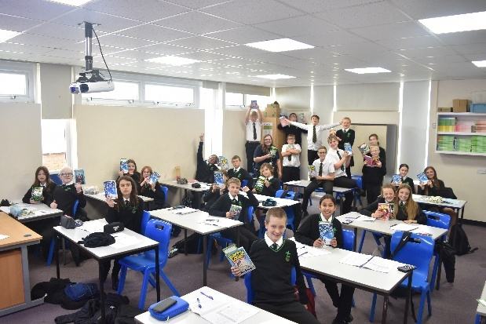Read aloud will be every day before lunch for 15 minutes. During this lesson, pupils will read aloud a text with their teacher. This will help pupils develop their ability to read confidently and fluently through widening their vocabulary. The ability to read confidently and understand a wide range of words is an essential life skill but also needed for pupils to reach their maximum potential in their exams. Explicit time to practise reading is often stopped when pupils leave their primary school education, we will not let this happen at GTS. We are carrying on this explicit focus on reading to ensure that pupils have the necessary reading ability to access the texts and vocabulary used in their GCSES.

A further aspect of reading which often slips by the wayside when pupils enter secondary school is the routine and culture surrounding reading. By pupils reading aloud every day we are fostering a culture of reading in our school. We aim for pupils to be exposed to a range of texts all pertaining to important themes in life, to help them become well-rounded individuals and to foster a love of reading.

## Personal Developement

Personal Development takes place once fortnightly. These 60 minutes a fortnight allow pupils to be mentored by their tutor or co-tutor and is a time for pupils to engage in team-based activities, alongside inter-house competitions, aspects of the PSHE curriculum, careers guidance and other relevant or current topics as they arise.

## Collective worship

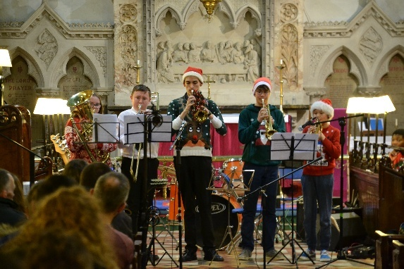

Collective worship is about a school’s duty to develop pupils spiritually, morally, socially, and culturally. This may include learning about interesting cultural traditions and their meaning, listening to stories with a moral message and reflecting on themes such as strength, courage, or loyalty. Collective worship should draw pupils’ attention to the values the school wishes to develop both as a body and in everyone. Collective worship is about the growth of the person, their character and social outlook, whatever their academic aptitudes.

All pupils have assembly* once a week as a house and meet in their tutor groups every morning for 15 minutes. This is time for the pupils to reflect and share suitable materials connected to collective worship.

**Right of withdrawal:** the right of withdrawal from collective worship stands for all parents and teachers.

## religious education

At KS3, we base our curriculum upon the Devon and Torbay Agreed Syllabus for RE. Pupils can opt to follow a full course GCSE in RE at Key Stage 4. All pupils will have discrete lessons RE in year 10 and 11 following an approved course at KS4.

**Right of withdrawal:***the right of withdrawal from RE or any part of the RE curriculum stands for all parents and teachers.*

## Extra-Curricular Opportunities

Additional to our Enrichment and Intervention provision, Great Torrington School has a breadth of activities which are available for pupils at lunchtime, after school and beyond. GTS believes that provision should go way beyond the taught curriculum as it is instrumental in building; character, values, relationships with peers and staff alike; as well as providing opportunities to build interests and passions that could last a lifetime.

Activities and events are developed in response to pupil requests/interests and identified gaps in the curriculum or community provision. Outdoor learning focuses on making the most of the local environment through surfing, orienteering, Duke of Edinburgh and Ten Tors. Events are often produced jointly with pupils, employers and community groups. Great Torrington’s Got Talent, Summer and Christmas concerts, GTS Film Premiere, Junior Sports Leader programmes, Rotary Club competitions such as Young Chef, Young Musician, Photographer and Writer of the Year and of course the Youth Speaks debating competitions, are all fine examples of what is on offer across the board.

In addition, a wide range of sport, music, drama, art, dance, science, language and geography activities/clubs are available. The library is open for pupils both before and after school and can be used for the completion of home learning. There is an active reading club with reading mentors every day of the week before school and during registration.

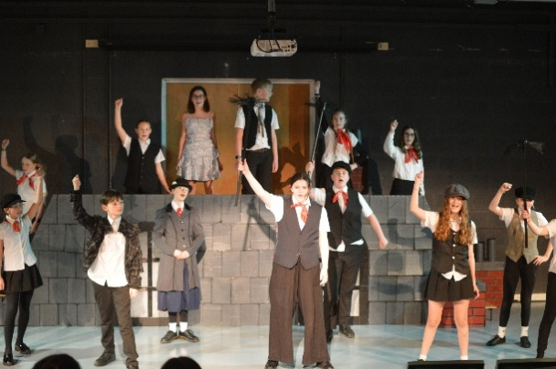

There are numerous trips covering a broad range of activities: outdoor pursuits in water sports in the Ardeche, the Ultimate Adventure Centre in Bideford and skiing in Italy. There are also History visits to the battlefields and Krakow, Geography field trips, language trips to France, Drama trips to London and even as far afield as New York! Pupils are able to follow the Duke of Edinburgh award at Bronze and Silver level.

Each term details are published with the upcoming extra-curricular activities.

## IMPACT

The impact of the taught curriculum is measured through attainment in public examinations and associated Key Performance Indicators (KPIs). To maximise progress for all pupils the outcomes will be analysed at an individual, class, subject and cohort level, which allows adjustments to future planning and implementation.

Equal significance is shown when assessing the impact of the extra-curricular provision on the pupil’s overall well-being, aspirations, engagement and wider development into a young adult. However, measuring this impact on social and emotional development is not as easily achieved; though factors like attendance, behaviour, contribution to the community and involvement in wider provisions is monitored.